## FORM FUNCTIONALITY DOCUMENT

This document is to show the functionality of each form if in any case the database importing process does not work out. However, this doument does NOT provide proof that the forms are bug free.

## 1. Registration Form (Only works when NOT logged in)

1.1 Customer first fills his/her details in the registration form.

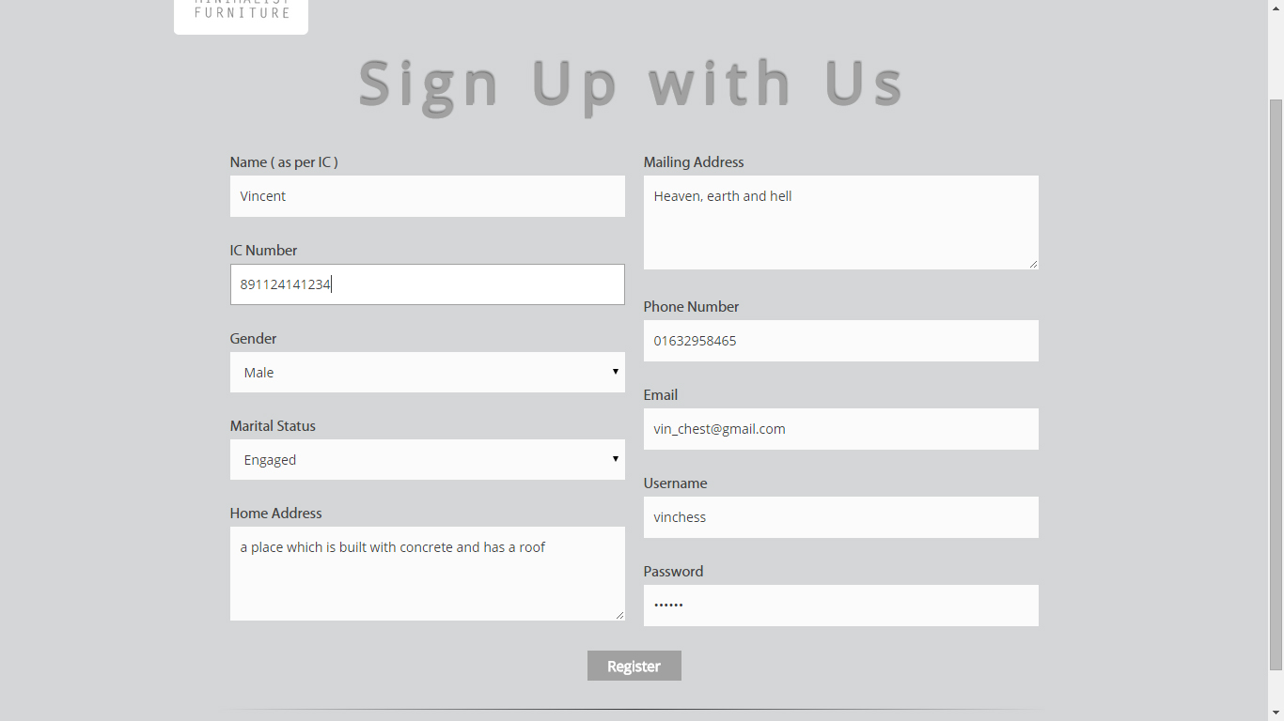

1.2 Upon clicking Register, the customer’s details is then stored into a *users* database.

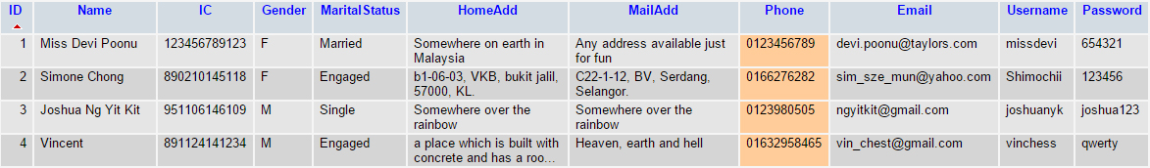

1.3 At the same time, the website will prompt a welcome message below to the customer upon successful registration.

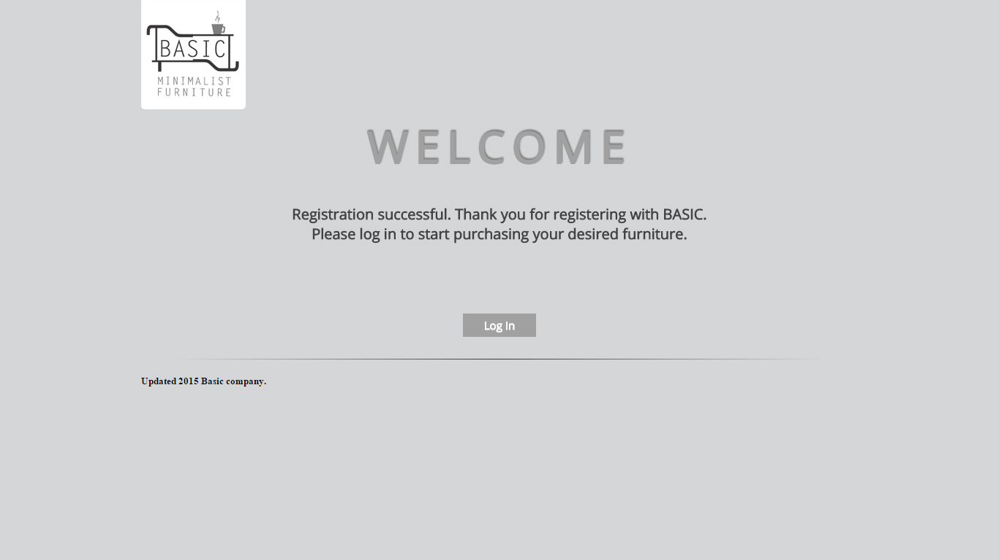

## 2. Login Form (Only works if NOT logged in)

2.1 Customers can log in by entering his/her username and password.

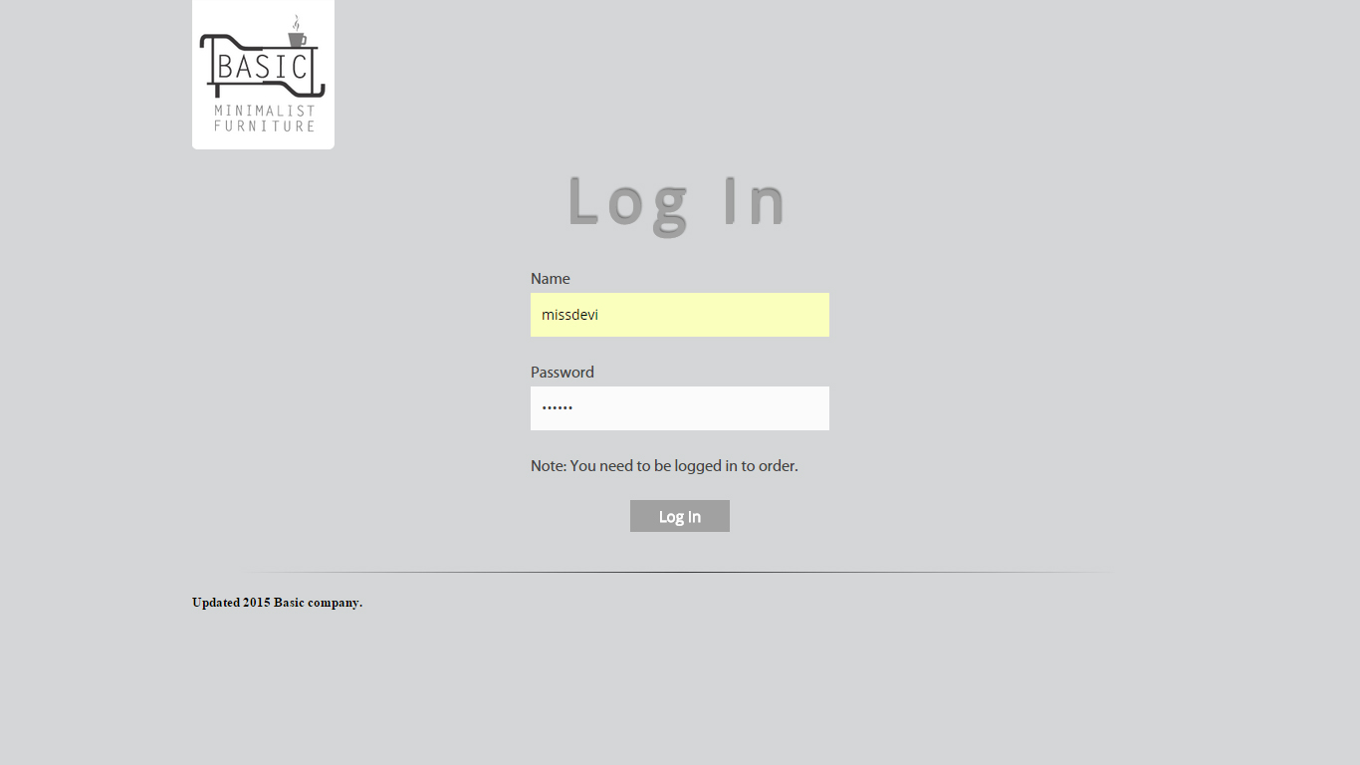

2.2 Once successful, the website prompts a personal welcome message to the customer to notify that the login is successful and it is the correct user.



2.3 But if username or password doesn’t match the databases, a different message will prompt to inform the customer that it is the wrong input.

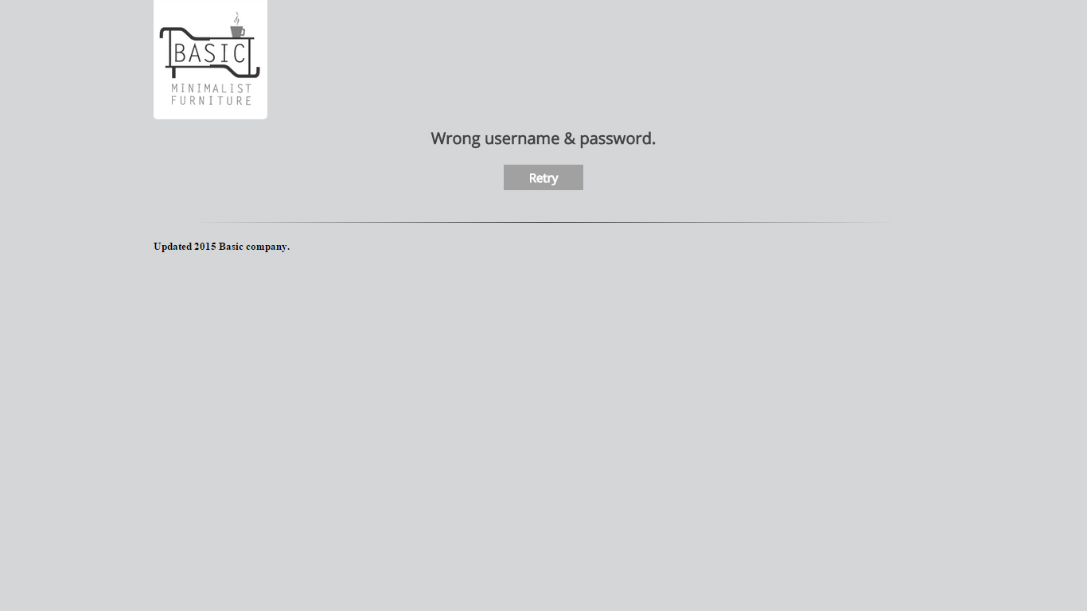

## 3. Order Form (Only works when logged in)

3.1 The customer can pick out the quantity of furniture he/she wants to purchase.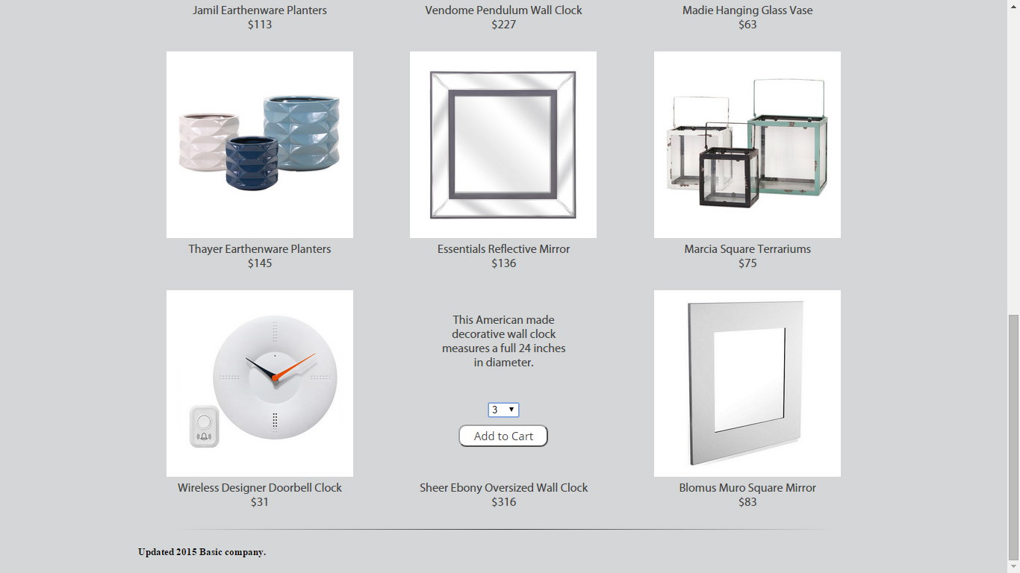

3.2 By clicking the Add to Cart button, the website then adds the furniture to the cart.

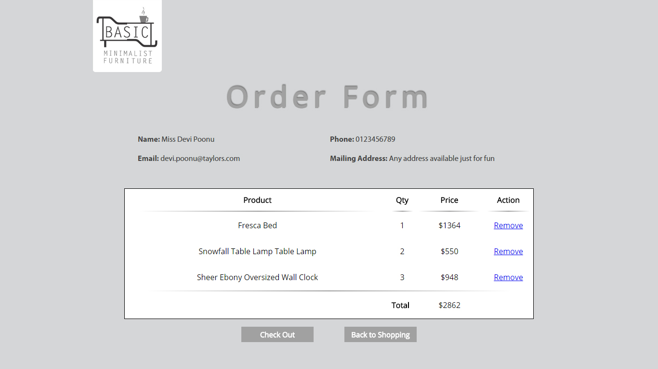

3.3 The customer can remove his/her order from the cart by clicking Remove.

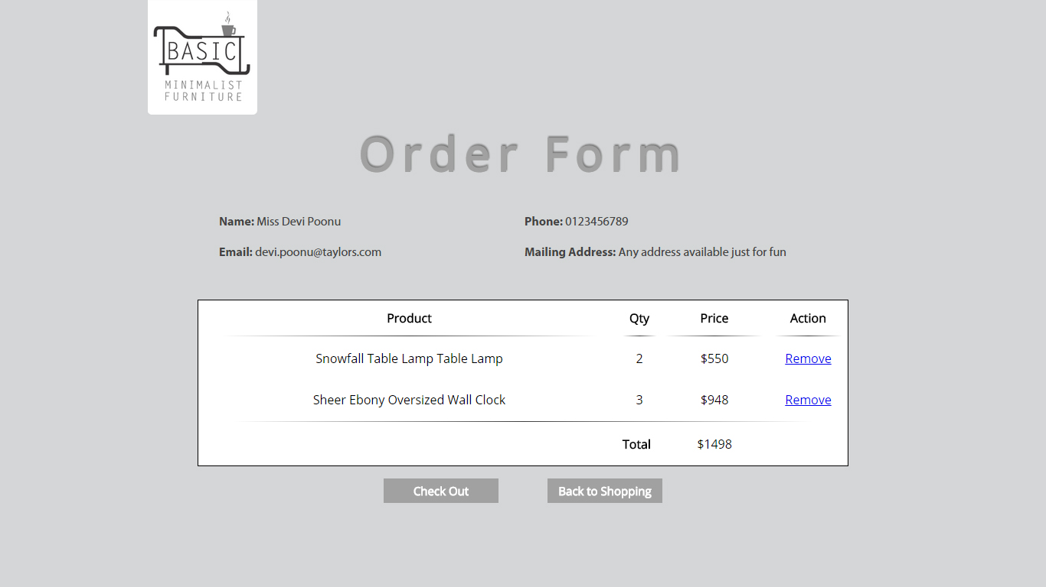

3.4 Lastly, the customer can choose whether to continue shopping by clicking the Back to Shopping Button or to check out his/her order by clicking the Check Out button. The Back to Shopping button will bring the customer back to the home page while the check out prompts a message to notify the customer that their order is recorded.

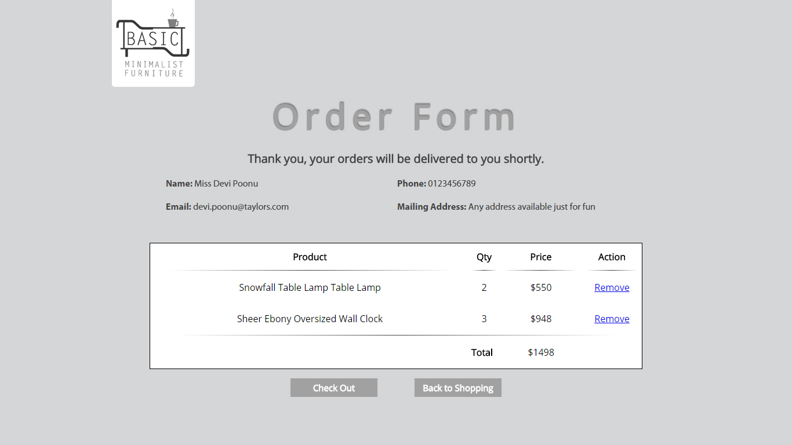

## 4. Search Form

4.1 The customer types in his/her desired furniture keyword into the search bar.

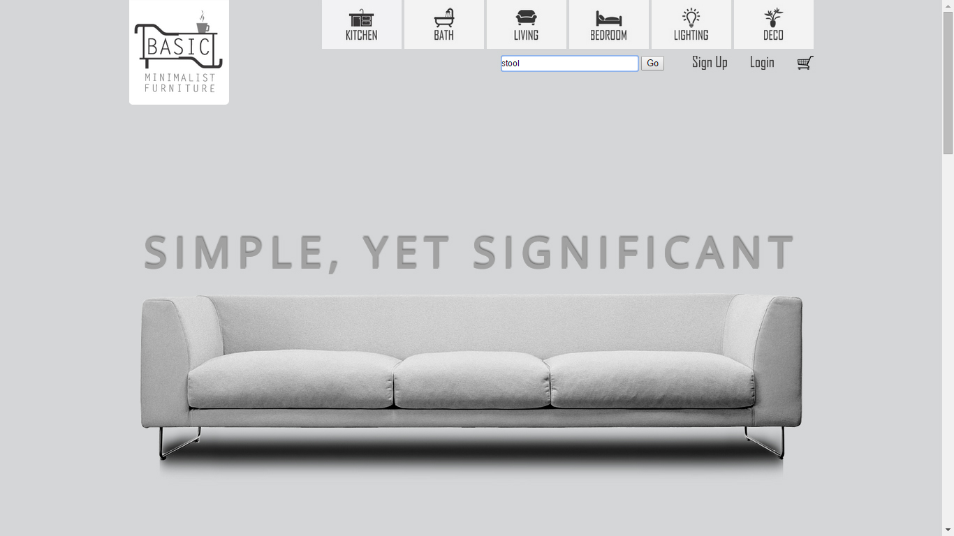

4.2 Upon hitting Go, the website then searches through the *inventory* database and displays the search results.

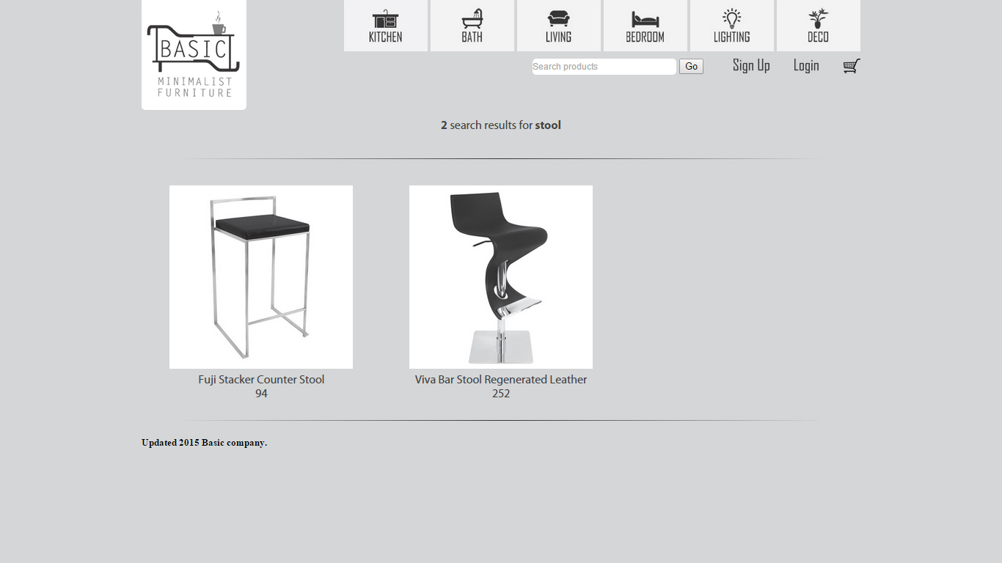

## 5. Feedback Form

5.1 The feedback form can be filled out without logging in.

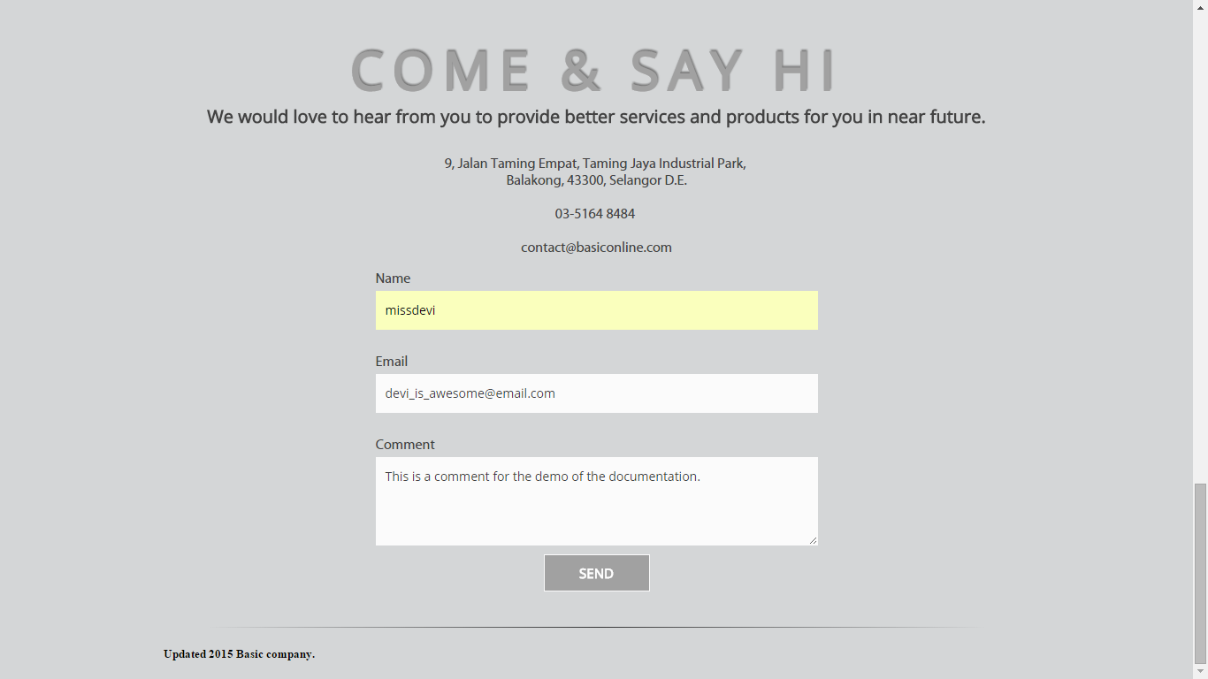

4.2 Hitting Send will save the data into the *feedbackpile* database.



4.3 This message will also be prompted for the customer to know that his/her feedback is recorded successfully.

